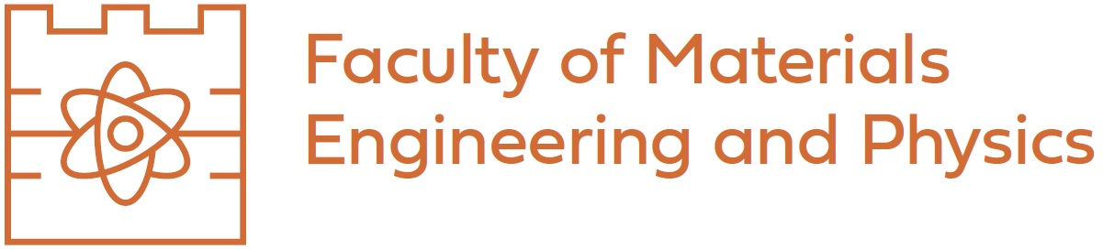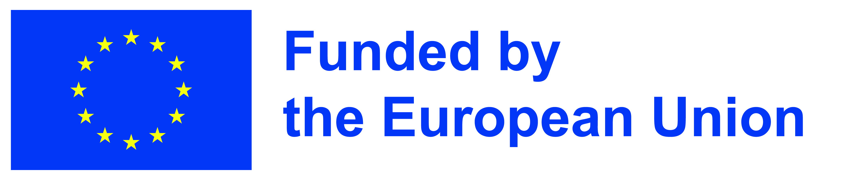
Course for Erasmus + program
Course title: | Introduction to welding technology
Place of the course in the University: | Department of Materials Engineering, Faculty of Materials Engineering and Physics
Number of contacts for a 45-minute class period: | 20
Course duration: | 1 semester
ECTS credits: | 6
Course description:
The course will cover the primary joining methods for engineering materials, including GMAW, MMA, submerged arc welding, RSW, FSW, soldering, and gluing. Furthermore, the use of a robot for welding using tandem (TWIN) technology and the additive process implemented using GMAW technology will be presented. The safety of use of these technologies, equipment (machines), process parameters, joint structure, and their properties will also be discussed. The laboratory section will include practical exercises in the application of selected technologies and the design of a welding process using a robotic cell. Knowledge will be assessed based on an in-class activity or a multiple-choice test.
Literature:
- Klas Weman, Welding processes handbook, Woodhead Publishing Ltd, Cambridge, England, 2003
- J. F. Lancaster, Metallurgy of welding, Abington Publishing Woodhead Publishing Limited, Abington Hall, Cambridge England, 1999
- A. F. Shevakin et al., Development and industrial exploitation of welding technology for heat-resistant nickel alloys for high-temperature nuclear power plants, Metallurgist (2024) 68:648–654, https://doi.org/10.1007/s11015-024-01770-x
- K. Mroczka et al., Comprehensive Research of FSW Joints of AZ91 Magnesium Alloy, Materials, vol. 16, no. 11. 2023, doi: 10.3390/ma16113953.
- X. Xie et al., Microstructure and Mechanical Properties of In-Doped Low-Temperature SnPb Solders, Materials (Basel)., vol. 18, no. 4, pp. 1–12, 2025, doi: 10.3390/ma18040886.
Course type: lectures (10 class periods), laboratory (10 class periods)
Prerequisites: none
Primary target group: Materials Science
Assessment method: oral answer, report on classes exercises
Lecturer: dr hab. inż. Krzysztof Mroczka, prof. PK
Contact person: e-mail: krzysztof.mroczka@pk.edu.pl

